**Homework #03**

**Problem 1**

Find CTFT of the following signals.



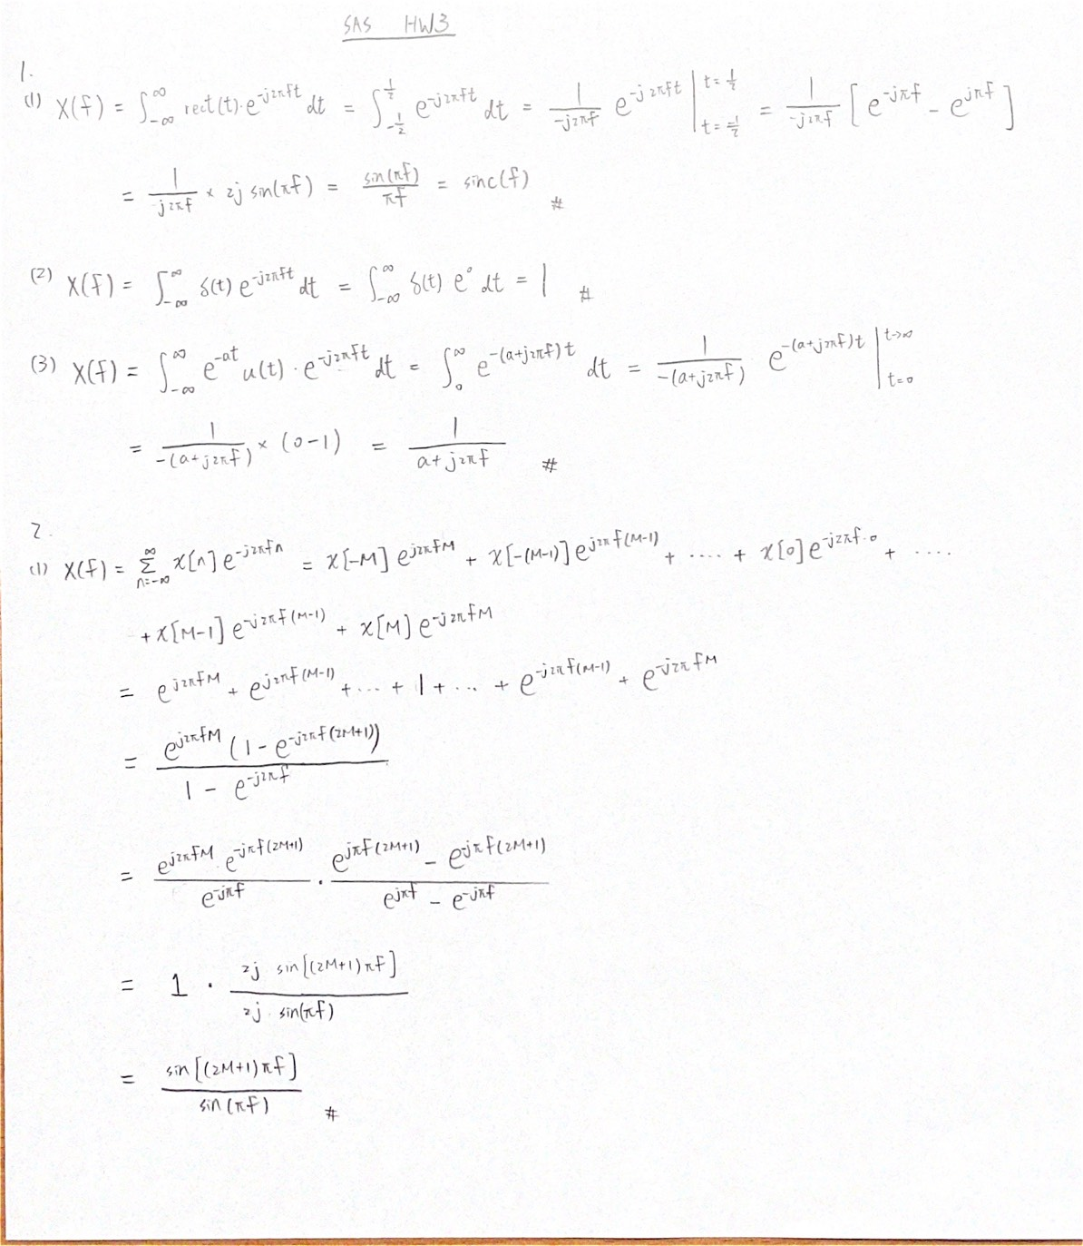









**Problem 2**

Find DTFT of the following signals.





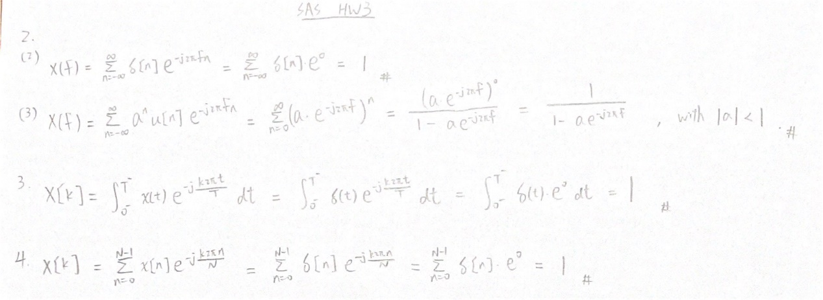



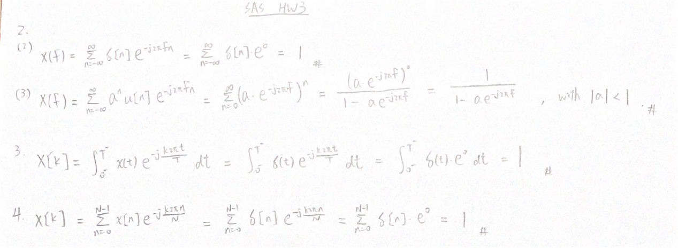

**Problem 3**

Find CTFS of the following signal.





**Problem 4**

Find DTFS of the following signal.





**Problem 5**

**Part I**

(a) f0 = 0.1 L = 64

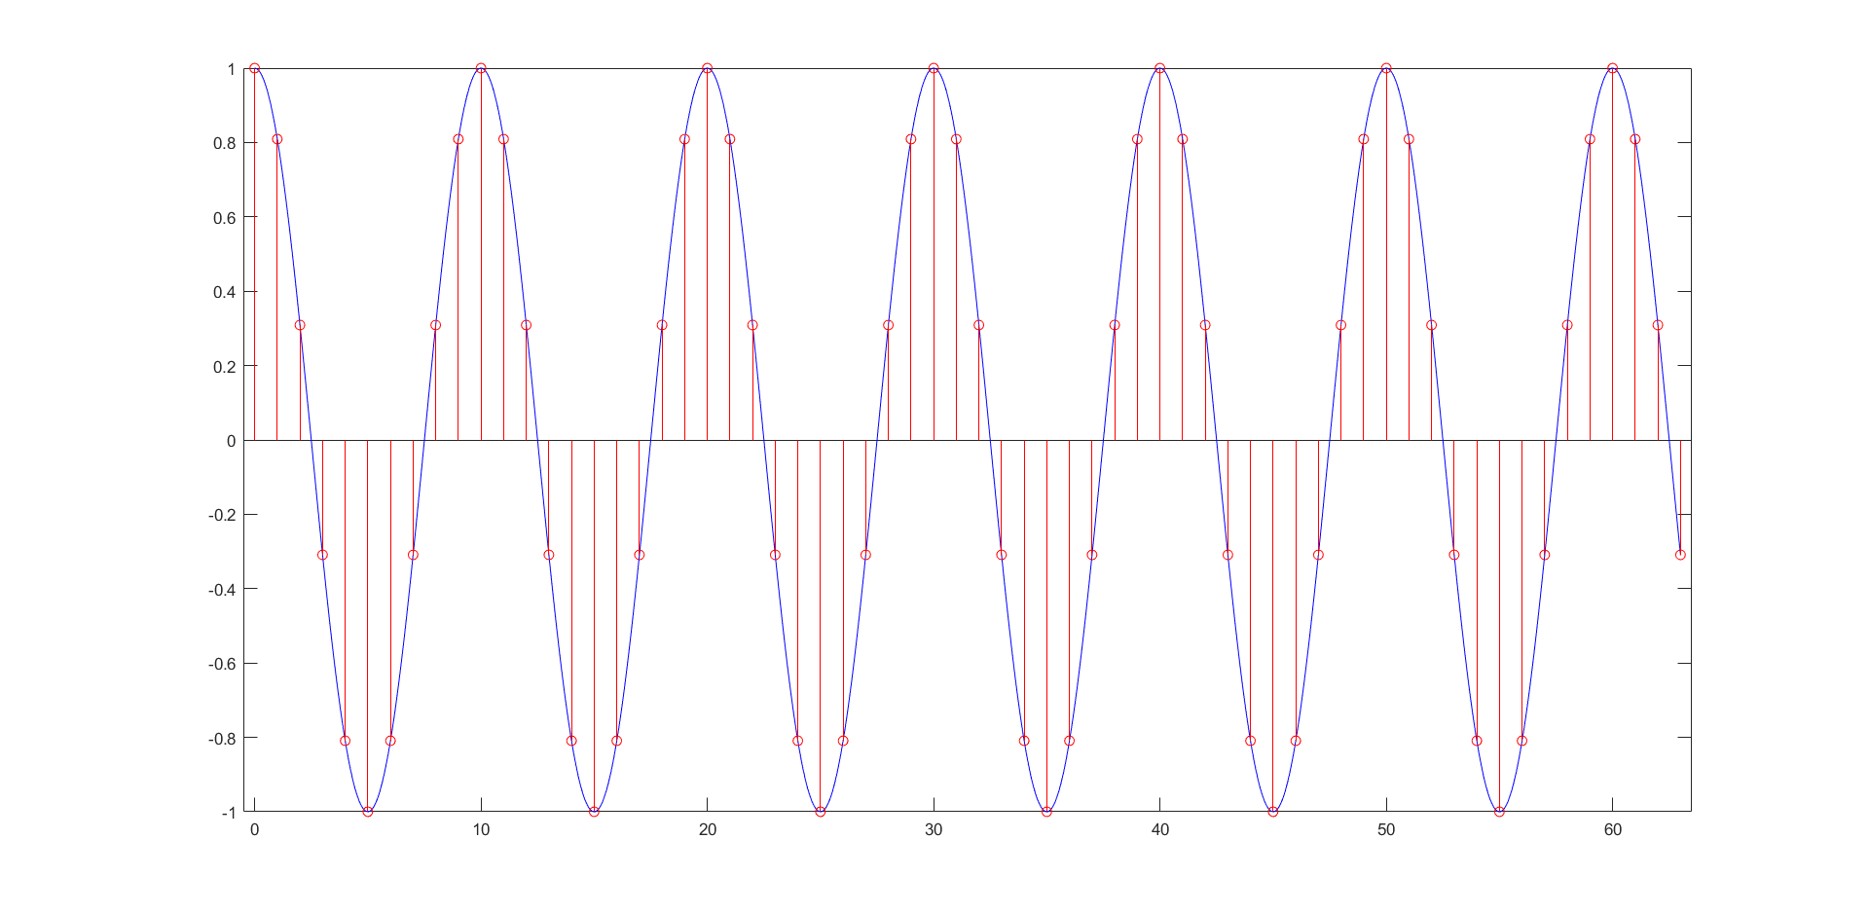

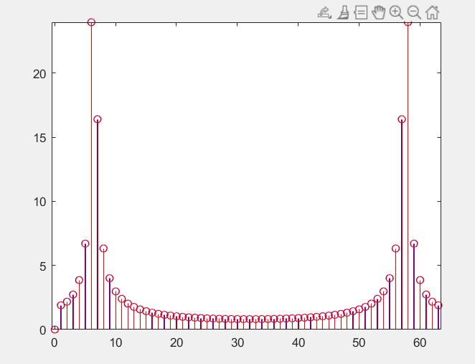

(b) f0 = 0.9 L = 64

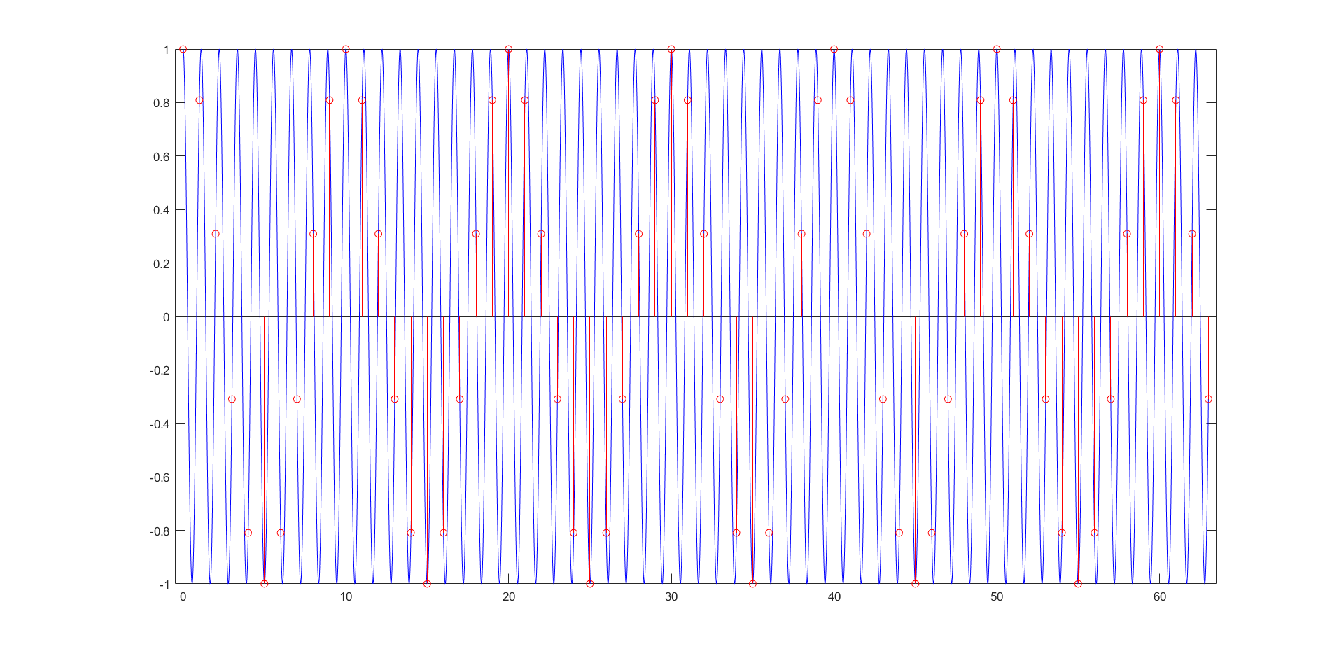

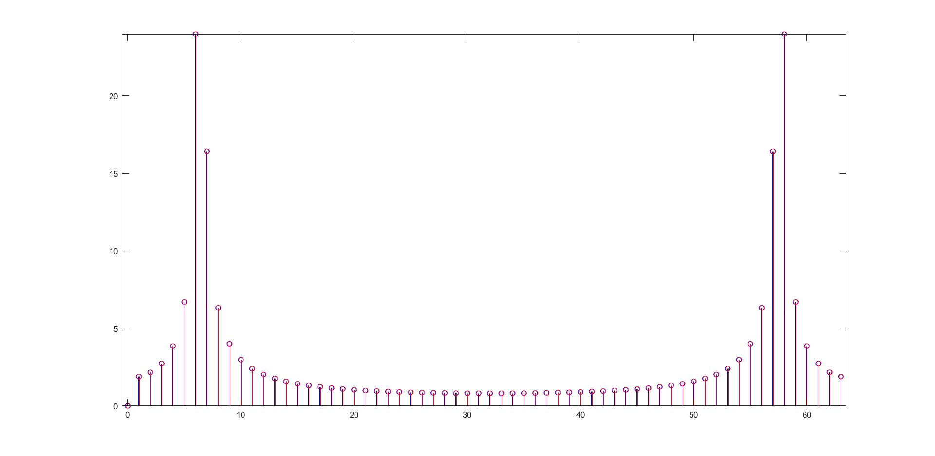

(c) Compare the results of (a) and (b).

Although the two frequencies are different, they are the same after sampling.

**Part II**

(a) f0 = 0.001 L = 64

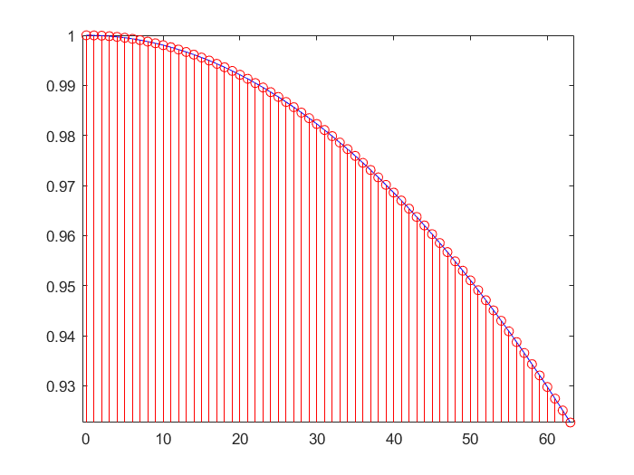

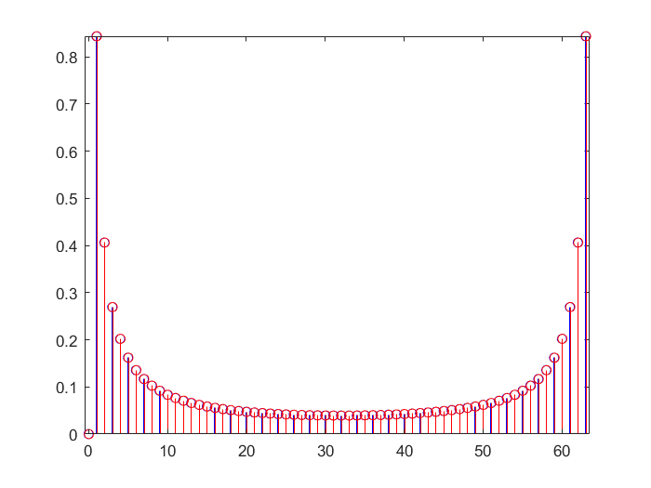

(b) f0 = 0.001 L = 1024

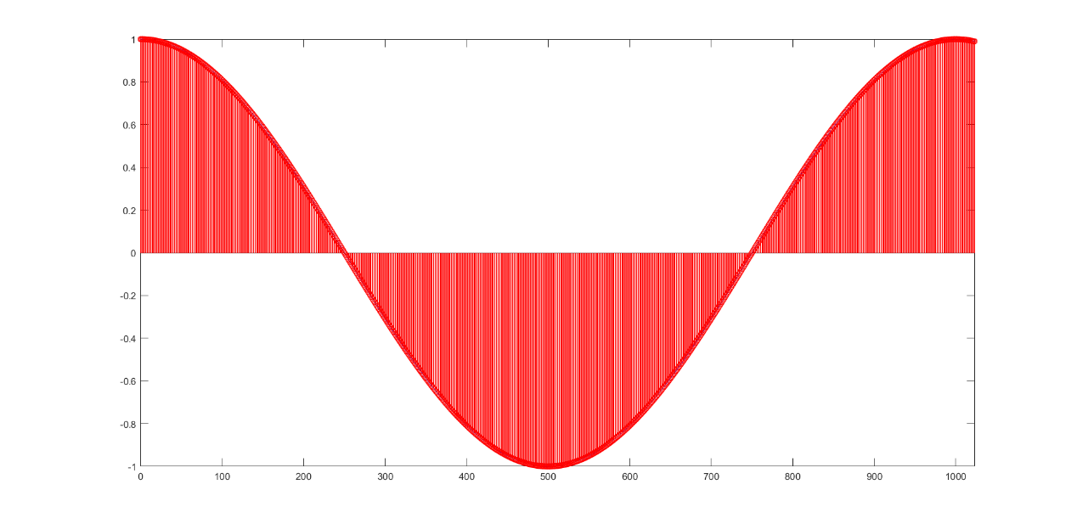

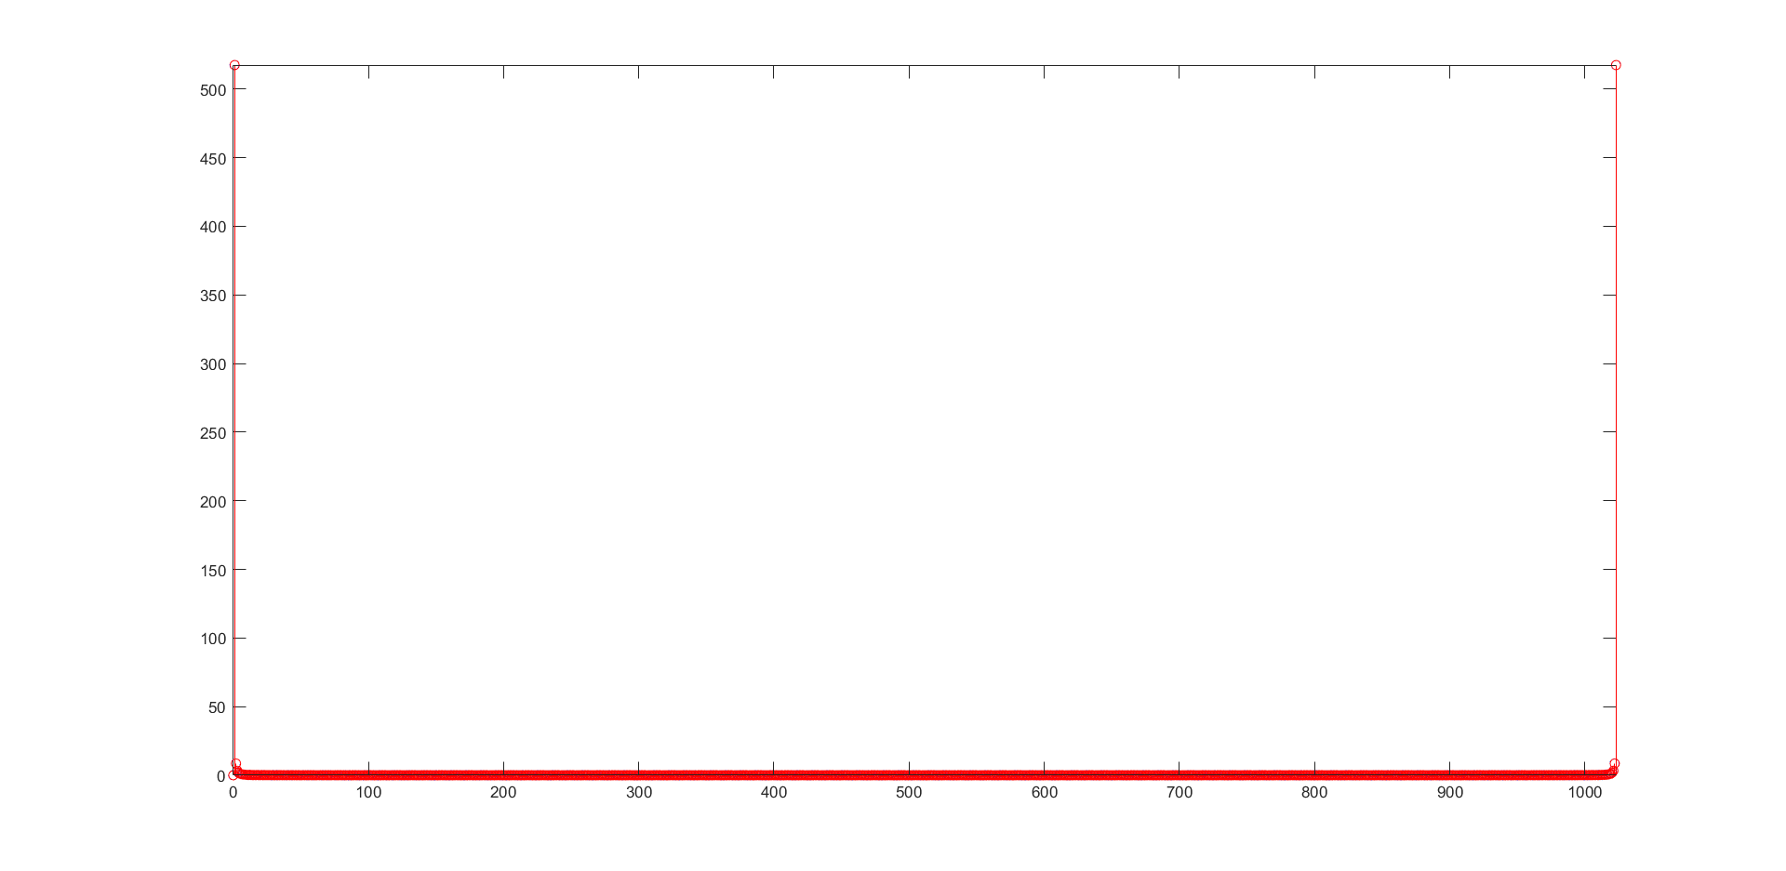

(c) Compare the results of (a) and (b).

Since the data length L of (a) is 64, that of (b) is 1024, (a)is the fronter part of (b).